COMPUTER FORENSICS ASSIGNMENT 2020

**Scenario**

Lard Land donuts, a doughnut making company in Springfield believe that one of their employees, Ms Penelope Olsen, is really a secret agent working for their competitor Dunkin’**Donuts. Penelope has access to the company’s prize asset, the secret recipe for ‘Honey Duff Donuts” Security staff are worried that Penelope has leaked the company’s secret recipe. The security staff have been monitoring Penelope’s activity for sometime, but haven’t found anything suspicious until now.**

**Today an unexpected laptop briefly appeared on the company wireless network. Staff hypothesize that it may be someone in the carpark, because no strangers were seen in the building.**

**Penelope’s computer (192.168.1.158) sent Instant Messaging packets over the wireless network to this computer. The rogue computer disappeared shortly afterward.**

**From the analysis of the packets, Exhibit B and Exhibit C attached below, the company believe they have been victims of a computer misuse attack and that the suspect is planning to leave shortly. They therefore decide to call in the Local police.**

Subsequent investigations into Ms Penelope Olsen indicate that the name is an alias and that she is Mrs Mona Simpson and is a wanted woman and that her last known address was with her son Mr H.J.Simpson. at 742 Evergreen Terrace. During the police search of 742 Evergreen Terrace they found a USB stick and a Mobile Phone (exhibitA). These items were removed for forensic analysis.

You as a forensic analyst have been provided with an image from the USB device.

Your task is to perform a forensic analysis of the image.

Looking at the phone it does not appear that it will yield any information.

**EXHIBIT B**

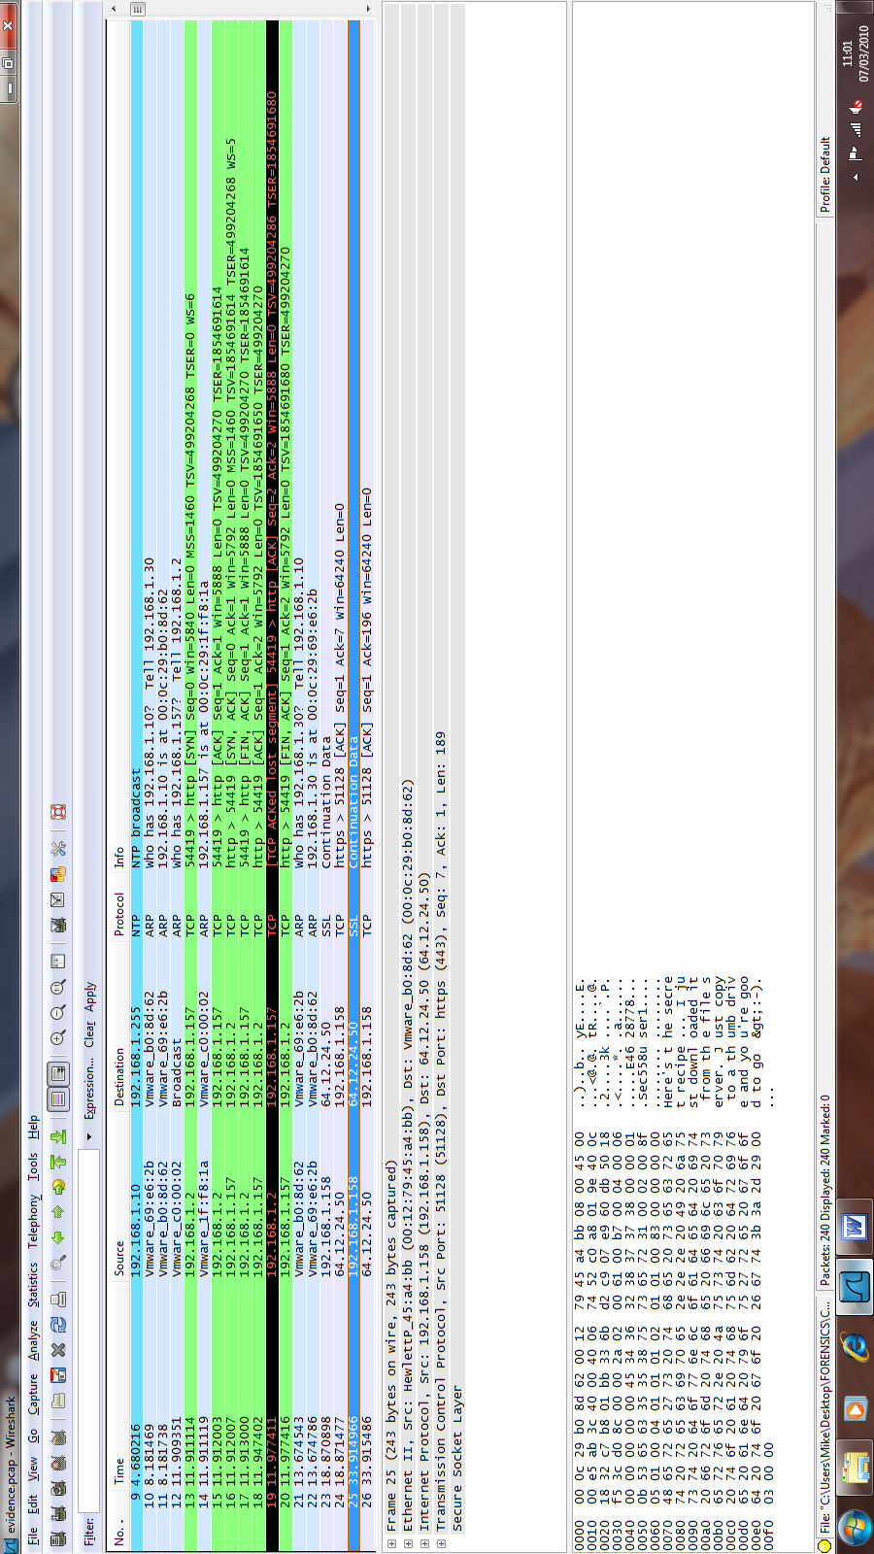

**EXHIBIT C**

